Copyright for test papers and marking guides remains with *West Australian Test Papers.*

They may only be reproduced within the purchasing school according to the advertised Conditions of Sale.

Test papers should be withdrawn after use and stored securely in the school until Friday 4th December 2009.

## PHYSICS

## YEAR 11

## 2A/2B

**2009**

### INSTRUCTIONS TO CANDIDATES

**TIME**: 3 Hour Paper: **MARKS: 200**

Attempt **ALL** questions

**STRUCTURE OF THE PAPER**

|  |  |  |  |  |
| --- | --- | --- | --- | --- |
| Section | No. of  Questions | No. of questions  to be attempted | No. of marks  out of 200 | Proportion of  exam total |
| A: Short Answers | 14 | ALL | 70 | 35% |
| B: Problem Solving | 8 | ALL | 100 | 50% |
| C: Comprehension and  Interpretation | 2 | ALL | 30 | 15% |

Note: Above refers to 3 hour paper.

**INSTRUCTIONS TO CANDIDATES**

Write your answers in the spaces provided beneath each question. The value of each question (out of 200) is shown following each question.

The enclosed Physics: Formulae and Constants Sheet may be removed from the booklet and used as required.

Calculators satisfying conditions set by the Curriculum Council may be used to evaluate numerical answers. The calculator **cannot** be a “**graphics”** calculator.

Answers to questions involving calculations should be evaluated and given in decimal form. Quote the final answer to not more than four significant figures. Despite an incorrect final result, credit may be obtained for method and working providing these are clearly and legibly set out.

Questions containing specific instructions to **show working** should be answered with a complete, logical, clear sequence of reasoning showing how the final answer was arrived at; correct answers which do not show working will not be awarded full marks.

Questions containing the instruction "**ESTIMATE**" may give insufficient numerical data for their solution. Students should provide appropriate figures to enable an approximate solution to be obtained.

**Section A: Short Answers**

Marks allocated: 80 marks out of a total of 200 (40%)

Attempt ALL questions in this section. Not all questions attract the same marks.

Answers are to be written in the space below or next to each question.

1. Below is a picture of an Esky, a familiar item used in summer.

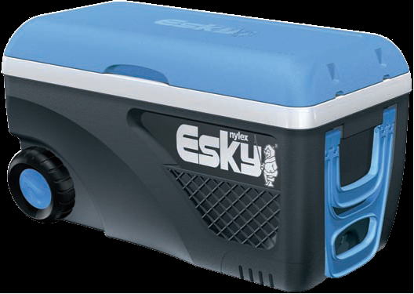

(a) A warm bottle of drink is placed in the esky that contains plenty of ice. List the physics principles involved in the Esky design and the process whereby the warm drink becomes cooler by being placed in the Esky for a while. (3 marks)

(b) Why does some ice remain frozen even after many hours? (1 mark)

In the following two multiple choice questions select the **best** answer and in the space provided give your explanation displaying your physics understanding.

2. When you drop a ball it will accelerate downwards at 9.8 m s-2. If instead you throw it downwards its acceleration immediately after leaving your hand, assuming no air resistance, will be:

(a) 9.8 m s-2.

(b) more than 9.8 m s-2.

(c) less than 9.8 m s-2.

(d) unable to say, unless speed of throw is given. (2 marks)

Reason for my choice: (2 marks)

3. When electric current flows through a tungsten filament as in an incandescent globe the filament becomes white hot. Compared to the current in the filament the current in the connecting wires is: (2 marks)

(a) less.

(b) more .

(c) the same.

(d) need more information.

Reason for my choice: (2 marks)

4. The Thrust SSC car raised the world speed record in 1998. The mass of the car was

1 x 104 kg. A 12 s run by the car may be considered in two stages of constant acceleration.

Stage one was from 0 to 4.0 s and stage two from 4.0 to 12.0 s.

(a) In stage one the car accelerates from rest to 44 m s-1 in 4.0 s. Calculate the acceleration and the force required to provide this acceleration. (1 +1 marks)

(b) In stage two it continued to accelerate until it reached a speed of 284 m s-1 in a

further 8.0 s. Calculate the acceleration in stage two. (2 marks)

5. In the Hopman Cup in Perth in January, Leyton Hewitt served at full speed.

In the parts to this question list any ESTIMATES you make before completing the question.



(a) ESTIMATE the change in momentum of the tennis ball during his serve. (2 marks)

(b) If his racquet had a mass of 300 g and the contact time of the ball on the racquet

was 0.2 s then what force would Leyton provide? (3 marks)

(c) Why do you think tennis players often have shoulder injuries? (1 mark)

6. The diagram below represents a network of resistors.

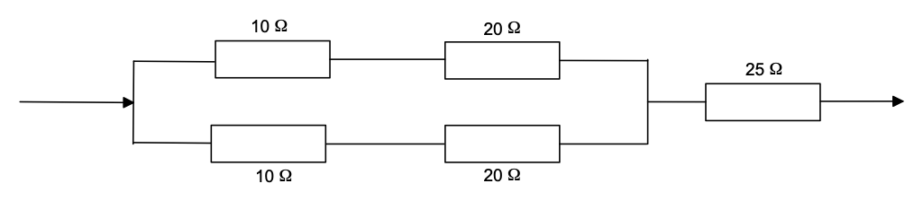

(a) What is the total resistance of this network? (3 marks)

(b) Which resistor will carry the largest current? (1 mark)

7. Solar water heaters are popular in Perth.

(a) In Perth which direction does the main panel face and for what reason? (2 marks)

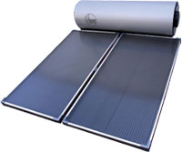

(b) The intensity of the sun is approximately 800 W m-2 and a typical heater would have an area of about 2m2. If the water was not circulating calculate the temperature increase in

30 min if the mass of water in the pipes in the panel is 15 kg.

(Specific heat of water = 4180 J kg – 1 K – 1) (3 marks)

8. You are going to investigate the absorption of nuclear radiation by different materials. You have a source that emits alpha, beta and gamma radiation and a sample of materials all the same thickness and a Geiger counter.

(a) Why should all the different absorption materials be of the same thickness? (1 mark)

(b) Draw a sketch to show how you would arrange the radioactive source, the sample material and the Geiger counter to conduct a fair investigation. (2 marks)

(c) If the sample is aluminium and as thick as a 20 c coin, fill in the following table using the words; High, Low, No reading

as compared to the reading if air was the absorbing material. (3 marks)

|  |  |
| --- | --- |
| Type of Radiation | Reading of Geiger counter |
| Alpha |  |
| Beta |  |
| Gamma |  |

(d) If a very strong magnet was introduced between the aluminium and the detector would the reading for gamma radiation be:

decreased increased no change

Circle the word(s) that best completes the above statement. (1 mark)

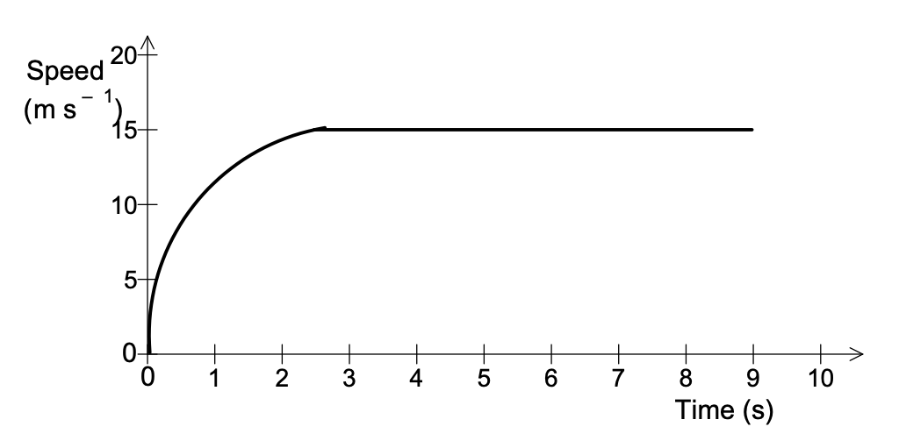9. The graph below represents the motion of a car of mass 1.4 x10 3 kg travelling in a straight line.

(a) Without calculations describe how the **resultant** force acting on the car varies over the 10 s period. (2 marks)

(b) Estimate how far the car has travelled after 6 s. (3 marks)

(c) Sometime later the car reaches a speed of 30 m s-1 and the useful power developed by the engine is 20 kW. Calculate the driving force required to maintain this speed. (3 marks)

10. Complete the following Nuclear equations and name the particle / radiation type. (3 marks)

(a)



(b)



(c)



11. Below is a photo of a double amputee athlete trying to qualify for the Beijing Olympics in 2008. His time for the 400 m was 46.25 s, only 0.11 s outside the qualifying time.

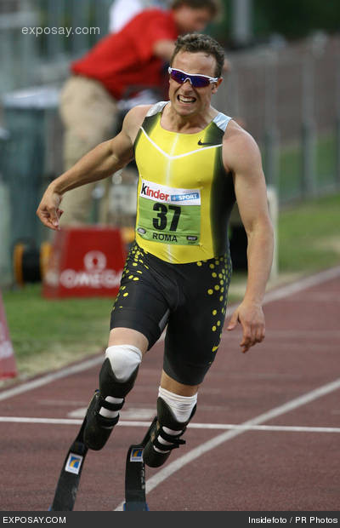

The South African Team could still nominate him for the 4 x 400 m relay team.

(a) Using high school physics principles explain why you are not surprised that a double

amputee can run so fast. (2 marks)

(b) What other event (other than running) would you expect him to perform well in?

(1 mark)

12. A student wishes to cool his 250 g soft drink (specific heat 3500 J kg - 1 K-1) from an initial temperature of 30 0C to a more pleasant 50 C.

(Latent heat of fusion of water = 3.35 x 10 5 J kg – 1)

(Specific heat of water = 4180 J kg – 1 K – 1)

(a) What mass of ice at 0 o C should he add? (4 marks)

(b) How could he make the cooling occur more quickly? (1 mark)

13. Calculate the electrical energy required to:

(Latent heat of fusion of water = 3.35 x 10 5 J kg – 1 )

(a) change the temperature of 500 g water in an insulated kettle from 250C to 100 0C.

(2 marks)

(b) calculate the extra energy required to boil half of this mass into steam at 100 o C.

(2 marks)

(c) If the kettle is connected to the mains (240 V) for how long will the kettle be on to provide 1000 Joules. The heating coil has a resistance of 5 ohms. (4 marks)

14. The following graph represents the data collected by measuring the radioactive activity as a function of time.

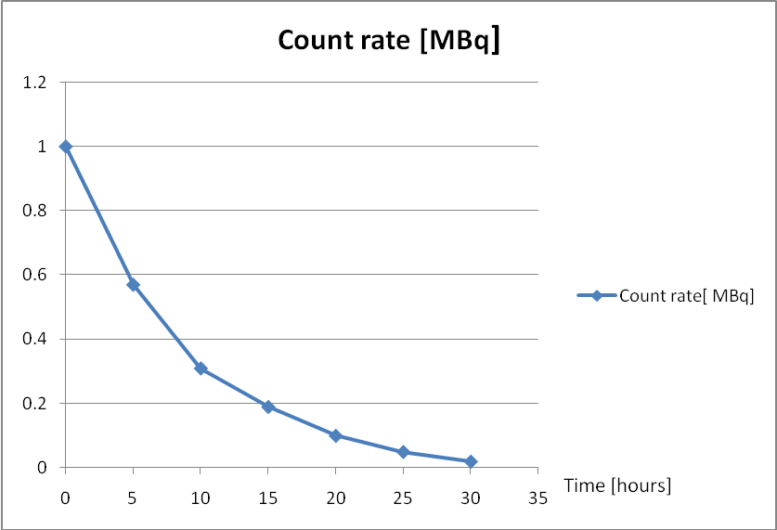

(a) Using the graph calculate the half life, T1/2 of this decay. (3 marks)

(b) Predict the activity after a time interval of four half lives. (2 marks)

**END OF SECTION A**

**Section B: Problem Solving**

Marks allotted: 100 marks out of a total of 200 (50%)

This section contains 8 questions.

Answer the questions in the spaces provided.

1. (13 marks)

Compact fluro globes are becoming more popular and soon you will not be able to buy the incandescent globes we have used for ages. A student noticed in the shop that one of these compact fluro globes was advertised at a rating of 18 W but with equal brightness to that of a 100 W conventional (incandescent) globe.

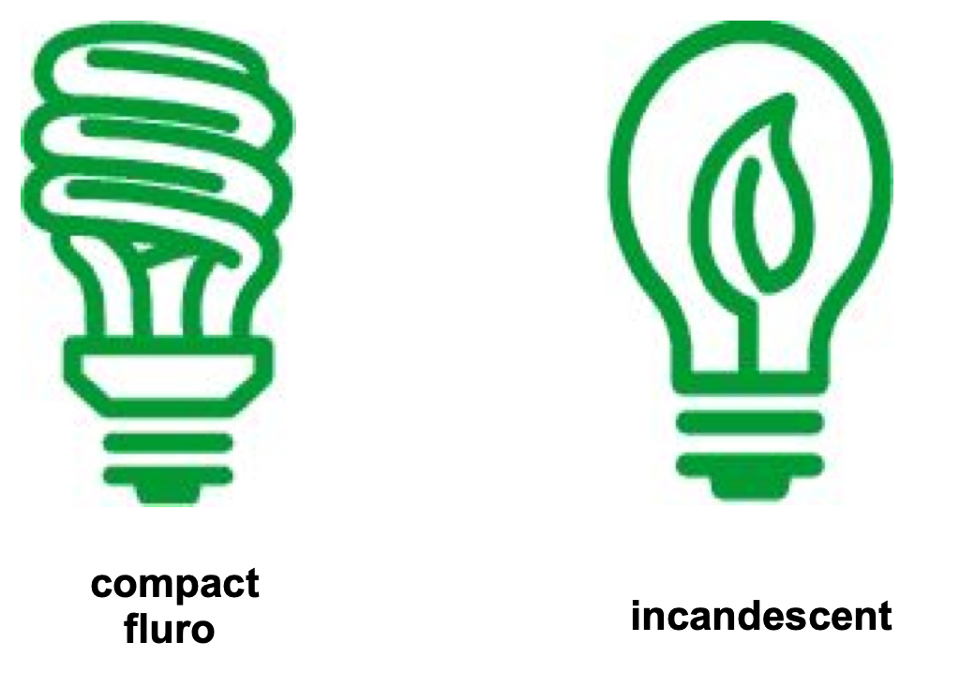

(a) What is the essential difference between these globes and why has the government phased out the incandescent globe? (1 mark)

(b) If the new globe is assumed to be 100% efficient, what was the efficiency of the

incandescent globe? (1 mark)

Now, the student decides to conduct an investigation relating to the heat output from each type of globe. He makes a circuit with each globe in parallel as shown below. Each globe is placed in an insulated cubic container of dimensions 0.8 m x 0.8 m x 0.8 m (volume = 0.5 m3) containing air. The insulated cubes are identical and a thermometer is placed in each and the current flowed for 5 min. A small fan (not shown) ensures the air is circulated inside the insulated cubes. The fan, for this question, consumes negligible energy.

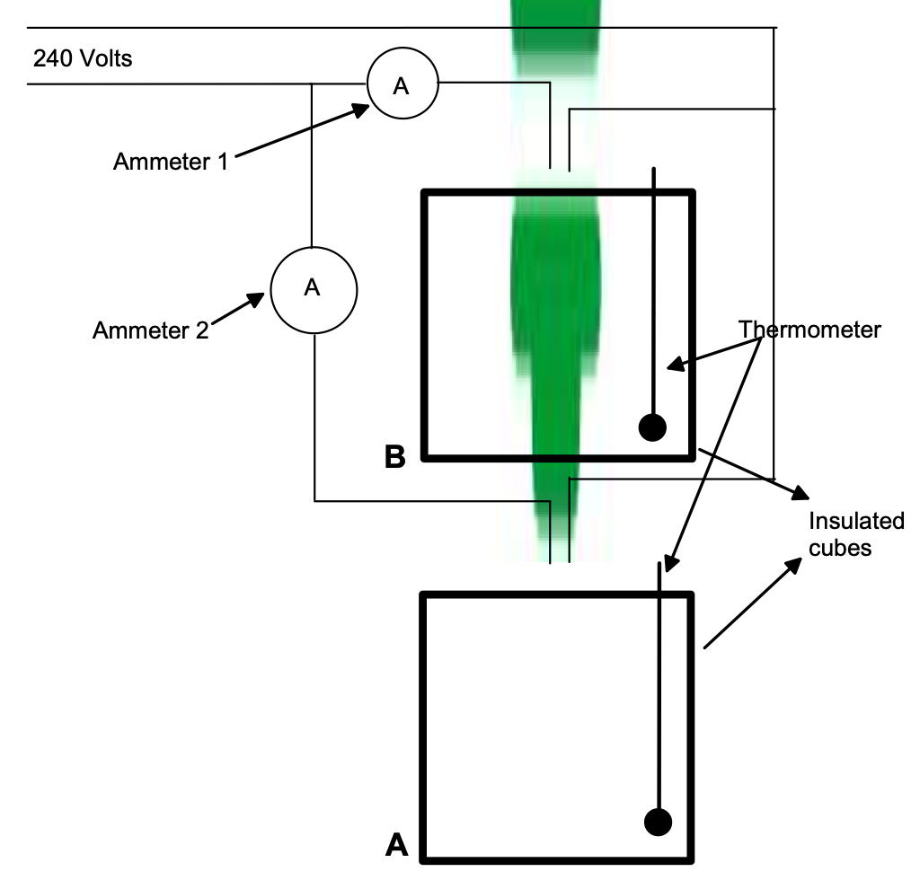

The following results were obtained,

Volume of air = 0.5 m3

Mass of each globe = 30 g

Initial temperature of air = 15 0C

Final temperature A = 40 0 C

Final temperature B = 20 0 C

The following data is duplicated on the Data and Constants sheet but may be useful in

this question.

Specific Heat of air = 1000 J kg-1 K-1

Specific Heat of glass = 650 J kg-1 K-1

(c) Make a conclusion based on the results table. (1 mark)

(d) Why were the globes connected in parallel? (1 mark)

(e) Calculate the heat output for both globe A and globe B in the 5 min experimental

period. (3 +2 marks)

(f) Calculate the ammeter reading for both ammeters. (2 +2 marks)

Ammeter 1 ……………………

Ammeter 2 ………………………

2. (12 Marks)

A student nurse of mass 80 kg accidentally absorbs 60.0 J of energy from a beta radiation source.

(a) Determine the absorbed dose. (2 marks)

(b) Determine the dose equivalent.  (2 marks)

(c) Determine the change in dose equivalent if the source had been an alpha source.

(2 marks)

(d) Comment on the effect (if any) that your answers to (b) and to (c) would have on the

nurse’s health. (1 mark)

(e) The radioisotope used that emits beta radiation had a half life of 30 years.

Its original activity was 900 MBq.

(i) Draw a graph to show how its activity would change over a period of 90 years.

(3 marks)

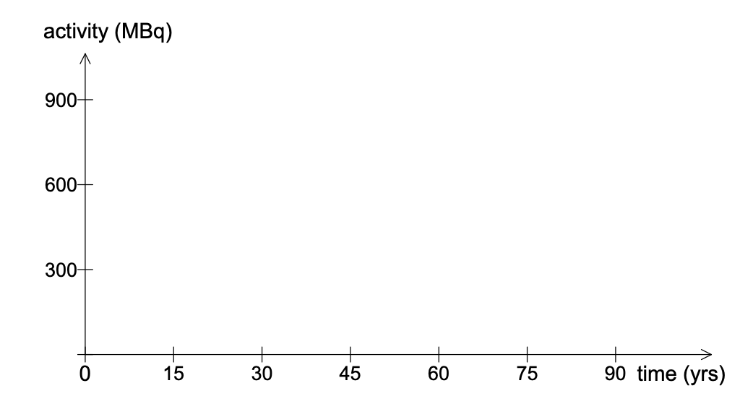

(ii) From the graph, or otherwise, calculate the activity after 90 years. (2 marks)

3. (13 Marks)

A typical nuclear reaction, which takes place in a nuclear reactor, is the fission of U-235 by a neutron to produce Xe-140 and Sr-94 as products, with the release of 2 neutrons and a large quantity of energy.

**Relevant information is provided on the Data and Constants sheet**

(a) Write a nuclear equation to represent this fission reaction. (2 marks)

(b) How much energy is released by the fusion of ONE uranium nucleus? (5 marks)

(c) Calculate the mass of U-235 needed to produce 100 MW of power for one year.

(6 marks)

4. (13 marks)

An electrical circuit is set up by a teacher to test students understanding of current, resistance and potential difference (voltage). The meters used in the circuit do not have any influence on the circuit other than to register current and potential difference. The students could see the readings on five of the meters but the teacher had covered the dials of three of the meters so the students could not see what they registered.

A diagram of the circuit is below

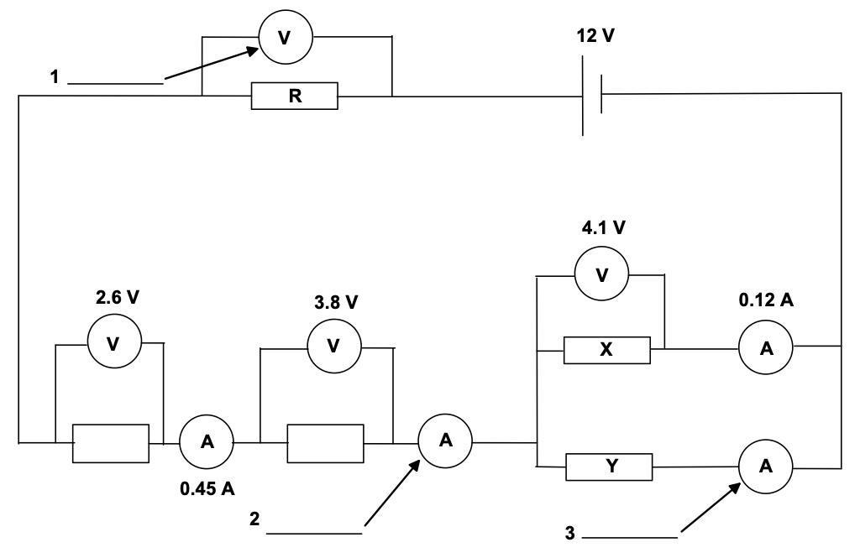

(a) Calculate what the readings on the meters 1, 2 and 3 would be, and write the

values next to the meters in the spaces provided. (3 marks)

(b) Calculate the resistance of X. (2 marks)

(c) Calculate the quantity of charge which flows through resistance Y in 5.0 minutes.

(3 marks)

(d) Calculate the value of resistance R. (2 marks)

(e) The battery can supply 1.4 MJ of energy. For how long could this battery operate if it constantly supplies this quantity of energy? (3 marks)

5. (13 marks)

In order to determine the specific heat of an unknown liquid students were encouraged to first find the heat generated by a Bunsen flame and then, later, using that same flame to heat a known mass of the unknown liquid. A diagram of the apparatus is shown below.



(a) List two good techniques a student would perform in this preliminary part of the experiment. (2 marks)

Initially the water was heated and the temperature rise recorded.

|  |  |
| --- | --- |
| Mass of water (kg) | 0.25 |
| Initial Temp of water ( 0C) | 20 |
| Final Temp of water ( 0C) | 55 |
| Change in temp of water ( 0C) |  |
| Time for which water was heated (s) | 240 |

(b) Use the formula

Q = m c DT

to find the heat generated by the Bunsen each second. (3 marks)

(c) Now before replacing the water with the unknown liquid the student was asked to list the main sources of error in the determination of the power of the Bunsen flame.

List two; (2 marks)

The water was replaced by liquid X and the results noted on the next page.

(d) In order for the results to be accurate list two conditions that the students should

have taken care to duplicate. (2 marks)

|  |  |
| --- | --- |
| Mass of liquid X (Kg) | 0.35 |
| Initial Temp of liquid X (0C) | 25 |
| Final Temp of liquid X (0C) | 65 |
| Change in temp of liquid X (0C) |  |
| Time for which liquid X was heated (s) | 220 |

(e) Determine the specific heat of liquid X showing all your calculations. (4 marks)

6. (13 marks)

(a) A new Qantas A380 aircraft lands at Perth International Airport for the first time. It is travelling at a velocity of 80.0 m s-1 when it first touches down on the runway. The aircraft takes 1200.0 m to stop after touching down.

(i) Estimate the momentum of a 75.0 kg passenger when the aircraft just touches down. (2 marks)

(ii) Calculate the average force acting on a 75.0 kg passenger as the aircraft

decelerates to a standstill. (3 marks)

(iii) If the same aircraft was involved in an emergency landing and had to stop in a distance of 400.0 m, by what factor would the average force acting on the passenger increase? (2 marks)

(b)

In a separate emergency landing an aircraft was travelling at 70.0 m s – 1 on touchdown and was required to stop in a distance of 400.0 m. In such a landing a constant large force of 240.0 N was exerted on a 80.0 kg passenger for a distance of 300.0 m.

(i) Determine the speed of the A 380 after travelling the 300 m. (3 marks)

(ii) Then a larger force was exerted for the final 100.0 m. Calculate the average force on the passenger for the final 100.0 m before the aircraft stops.

(3 marks)

7. (13 marks)

In an experiment to determine the latent heat of ice a student used the familiar apparatus below.



Ice, that was previously dried with a tissue, was added to the water in the beaker which was insulated until a significant temperature drop was recorded. The mass of the beaker was then reweighed. The liquid was stirred continuously.

(a) Why was the beaker insulated and why was the mass of ice not measured by first weighing it and then adding to the insulated beaker? (2 marks)

(b) Why did the student dry the ice with a tissue before adding it to the water? (1 mark)

(c) If room temperature was 25 0C, why was starting the experiment at 40 0C and

concluding at approximately 10 0C a good experimental technique? (2 marks)

The student tabulated the following results:

|  |  |
| --- | --- |
| Mass of water before adding the ice (g) | 100 |
| Mass of water after adding ice (g) | 135 |
| Initial temperature (0C) | 40 |
| Final temperature after adding the ice (0C) | 10 |
| Mass of ice (g) |  |

(d) Using the students data calculate the Latent Heat of ice. (6 marks)

(e) Determine the % error between your value and the accepted value of

3.3 x 105 J kg-1 and comment on the accuracy and techniques the student used.

(2 marks)

8. (10 marks)

Below is a simplified diagram of the wiring in a small house.

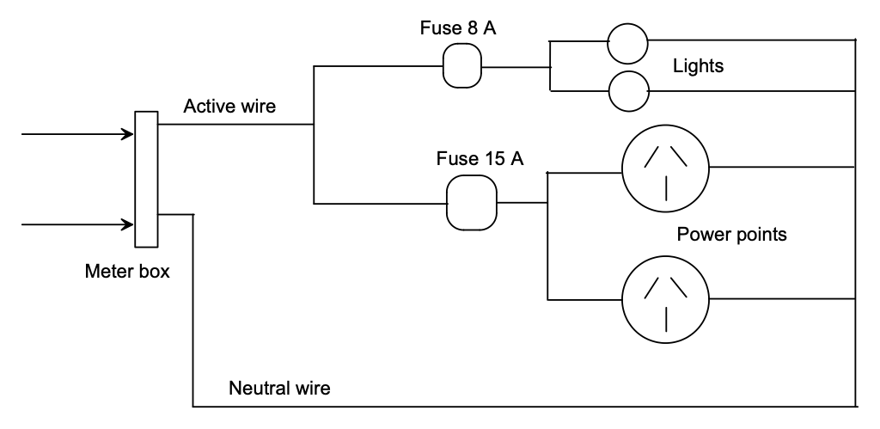

(a) What function does a fuse play in an electrical circuit? (2 marks)

(b) Why are the fuses for the lights circuits rated at a smaller electrical current than those for the power points? (2 marks)

(c) Connected to the power points are:

(i) a toaster rated at 750 W;

(ii) an electric fire rated at 1.5 kW.

Connected to the lights circuit are 2 globes each rated at 60 W.

Calculate the total energy used if all these are switched on simultaneously for 2 hours.

(3 marks)

(d) Calculate the cost of running these appliances if 1 unit of electricity 1 kW h costs

15 cents. 1 kW h is a unit of energy. It is defined to be the energy used by a 1 kW appliance when used for 1 hour. (3 marks)

**END OF SECTION B**

**Section C: Comprehension and Interpretation**

Marks allotted: 30 marks out of 200

Question 1 (20 marks)

Global warming - are wind and solar the solution?

In the light of the debate about global warming it is clear that coal and oil will not be the preferred fuels in the late 20tth century. Even the huge American oil/gas companies are looking to invest in new fuels. Can it be that solar and wind will be solutions?

These two energy sources offer interesting options in the energy mix.

**Solar**

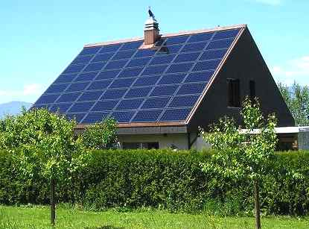

Solar cells convert, inefficiently, solar radiation into electric current. As demand increases they are becoming cheaper thanks in part to government subsidies and can be installed on the roof of a conventional house. It is reported that a 8 m2 panel will supply all the electricity demands of a normal house and any excess can be directed to the grid and sold back to the government.

The efficiency does not increase surprisingly with the temperature of the solar radiation and this has made Germany, which enjoys a mild climate, a leader in solar technology.

Solar farms that have been built to produce industrial quantities of energy have not been as successful and that is where wind comes into the mix.

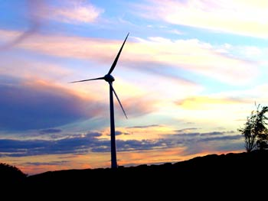

**Wind**

The first generation wind turbines like the one at Rottnest Island were noisy, killed birds, were ugly and did not provide substantial energy. Science has moved on and the turbines at Albany are larger, slower and quieter. A turbine with blades each of length 30 m rotating at 15 revolutions per minute, in a wind speed of 14 m s-1, will generate 2 MW and will be superseded in 2011 by a larger diameter turbine that can generate 4 MW. A direct drive gear box and the facility to twist the blades in high winds have made the new turbines much quieter. The wind generators produce AC whereas the output from a solar cell is DC. Once built, the facility has only minor running costs compared to a coal powered station.

Questions.

1. Why are oil and gas becoming environmentally unpopular? (2 marks)

2. Why are wind and solar attractive alternatives as sources of energy? (2 marks)

3. Why do you think solar energy production is useful for households but will never power an industrial complex like Alcoa, the giant producer of aluminium? (1 mark)

4. Why is it attractive to consumers to the purchase of solar cells with a capacity of 2 kW to supply their household needs? (2 marks)

5. Do you think wind turbines are ugly and should their appearance be considered when constructing wind farms? Explain your answer. (2 marks)

6. Why is the AC output from a wind turbine preferred to a DC output as in solar cells?

(2 marks)

7. Both wind and solar are described as “diffuse and unreliable” by the oil barons in Texas. What do they mean by these words? (2 marks)

8. If a typical home, on average, consumes 2 to 3 kW then ESTIMATE how many homes a new generation wind turbine could power? Show your working. (3 marks)

9. What is the speed of the tip of the blade of the turbine at Albany when it is generating

2 MW? (2 marks)

10. Why is Western Australia ideally suited to using wind generated electricity? (2 marks)

Question2 (10 marks)

Stokes Law

When a ball bearing is dropped into a viscous fluid then there are two forces acting on the

ball bearing:

1. The force of gravity – the ball bearings weight.

2. A viscous, friction force due to the liquid.

When the ball bearing reaches its maximum speed (its terminal velocity) then these two forces are equal and opposite, and being balanced, the ball continues on its journey at constant speed (the terminal velocity). This is the physics behind the parachute. The parachutist reaches the same final speed no matter at which height they leave the support plane.

This terminal speed of the ball bearing depends upon:

1. the liquid;

2. the diameter of the ball bearing.

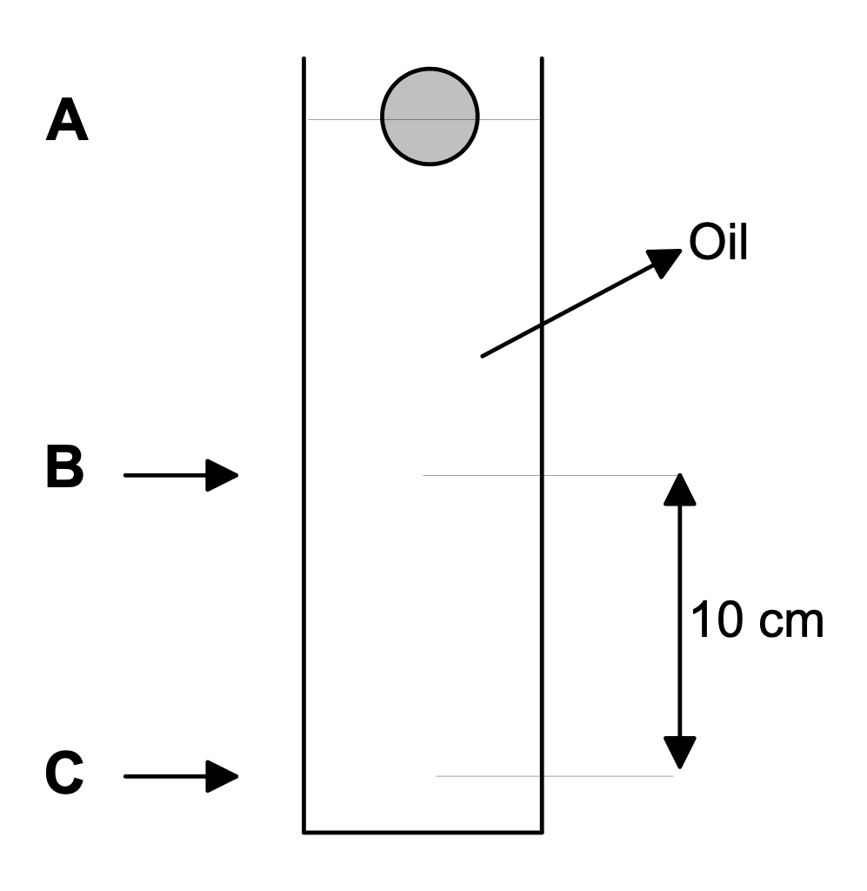

A student performed an experiment by dropping a ball bearing into a viscous liquid as shown above. He established that the ball bearing had reached its terminal velocity at B and measured the time to travel from B to C for different ball bearing sizes. All the ball bearings were made of the same material. He recorded his results in a table like the one below.

|  |  |  |  |
| --- | --- | --- | --- |
| Diameter of ball  bearing (cm) | Time to travel  B to C (s) | Terminal speed  (cm s-1) |  |
| 0.1 | 5.02 |  |  |
| 0.2 | 1.67 |  |  |
| 0.3 | 0.83 |  |  |
| 0.4 | 0.50 |  |  |
| 0.5 | 0.31 |  |  |

1. Sketch a graph of the speed of the ball bearing on its journey A to B to C.

Assume it started from rest. No numerical values are required. (1 mark)

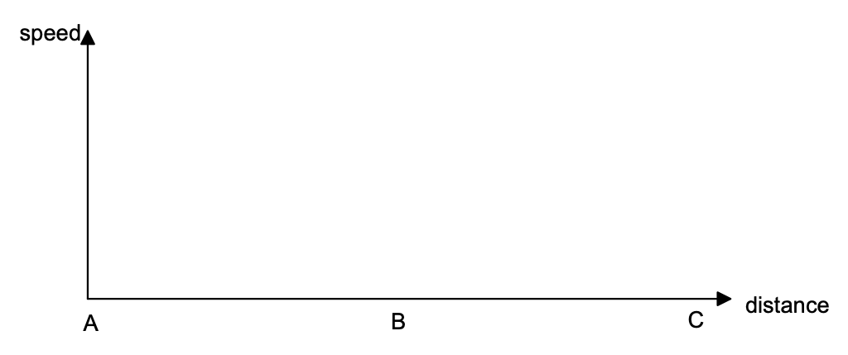

2. Fill in the column labelled terminal speed (cm s-1) (2 marks)

3. Plot a graph terminal speed (y axis) against diameter of ball bearing (x axis) and make a conclusion. (2 + 1 marks)



4. Scientists like to work with linear graphs. Use the data in the table to calculate a new set of data that can be used to create a linear graph. Enter this new data in the right hand column of the table. (2 marks)

5. Plot the new data on the grid below to demonstrate a linear plot. (2 marks)



**END OF EXAM**